1.5W, 5kV_{RMS} Complete Isolated DC-DC Converter

Features
- Complete Switch Mode Power Supply
  - High integration with internal transformer
  - Soft-start reduces input inrush current and output overshoot
  - Hiccup current-limit protection
  - Thermal shutdown
- 4.5 V to 5.5 V Input Voltage Range
- Selectable Output voltages
  - 3.3V and 5V output options
  - 3.7V and 5.4V output options provide headroom voltage to power LDO
- Delivers up to 1.5W(5V/300mA) Typical Output Power
- Excellent Load Transient Response
- Complies with CISPR32 Class B Radiated Emissions
- Up to ±3kV HBM and ±2kV CDM ESD protection
- Robust Galvanic Isolation Barrier
  - High lifetime: > 40 years
  - Up to 5kV_{RMS} isolation rating
  - ±150 kV/μs typical CMTI
- Wide Operating Temperature Range: -40°C to 125°C
- Low Profile SOIC16-WB (10.30mm×7.50mm) Package
- Safety-Related Certifications
  - VDE certification according to DIN EN IEC 60747-17(VDE 0884-17):2021-10
  - UL certification according to UL 1577
  - CQC certification according to GB4943.1-2022
  - TUV certification:
  - according to EN 61010-1
  - according to EN 62368-1

Applications
- Instruments and Apparatuses
- Industrial automation
- Motor Control
- Medical Equipment
- Industrial Sensors
- Telecom Equipment

General Description
The CA-IS3115AW is a family of complete isolated DC-DC converters with up to 5kV_{RMS} isolation rating. These devices integrate most of the components needed for an isolated power supply —switching controller, power switches, transformer, soft-start, protection circuit etc. — into a single, compact SOIC package. The result is an efficient and compact fully integrated solution that is easy to comply with EMI requirements and makes power-supply isolation design as easy as possible. Operating over an input voltage range of 4.5V to 5.5V, the CA-IS3115AW devices provide a fixed output voltage of 3.3V, 3.7V, 5V or 5.4V set by pin SEL. 3.7V and 5.4V output options provide headroom voltage to power an LDO. Only output, input bypass capacitors, and a pull-up resistor for 3.7V or 5.4V outputs are needed to finish the design.

The CA-IS3115AW devices feature a unique control scheme, which can quickly respond to load transient and accurately regulate the output voltage. The devices are capable of delivering a load up to 1.5W output power and offering soft-start, current limit, short-circuit protection and thermal shutdown protection features to better enhance the reliability of the system. The CA-IS3115AW devices include an enable input pin (EN). Connect the EN pin to the VINP input voltage or force this pin high to turn on the DC-DC converter. Force this pin low to disable the device and enter shutdown mode. In shutdown mode, the device stops switching operation with microampere standby supply current.

The CA-IS3115AW devices are available in wide-body SOIC16 package with creepage and clearance > 8mm, and operate over -40°C to +125°C temperature range.

Device Information
Part number | Package | Package size  (NOM)
CA-IS3115AW | SOIC16-WB(W) | 10.30 mm × 7.50 mm

Simplified Block Diagram

Ordering Information

Table 4-1. Ordering Information
Part # | Output Power (W) | Isolation Rating(kV_{RMS}) | Package
CA-IS3115AW | 1.5 | 5.0 | SOIC16-WB

Table of Contents

1 Features 1
2 Applications 1
3 General Description 1
4 Ordering Information 2
5 Revision history 3
6 Pin Configuration and Description 4
7 Specifications 5
7.1 Absolute Maximum Ratings^{1, 2} 5
7.2 ESD Ratings 5
7.3 Recommended Operating Conditions 5
7.4 Thermal Information 5
7.5 Power Ratings 5
7.6 Insulation Specifications 6
7.7 Safety-Related Certifications 7
7.8 Electrical Characteristics 8
7.9 MSL 8
7.10 Typical Operating Characteristics 9
8 Detailed Description 13
8.1 Overview 13
8.2 Output Voltage Selection 13
8.3 Protection Functions 14
8.3.1 UVLO and Soft-Start 14
8.3.2 Current-limit Protection 14
8.3.3 Thermal Shutdown 14
9 Applications Information 15
9.1 Typical Application Circuit 15
9.2 Input and Output Capacitors 15
9.3 PCB Layout Guidelines 15
10 Package Information 17
11 Soldering Temperature (reflow) Profile 18
12 Tape and Reel Information 19
13 Important statement 20

Revision history

Revision Number | Description | Revised Date | Page Changed
Preliminary Version | N/A | 2023/10/17 | N/A
Version 1.00 | Update isolation ratings | 2023/12/01 | 6,7
Version 1.01 | Adds output derating curves | 2024/01/03 | 11,12
Version 1.02 | Adds Short circuit protection function description | 2024/01/09 | 14
Version 1.03 | Update VDE, UL, CQC, TUV information  Update the test conditions of V_{IOSM} | 2024/04/16 | 1,6,7
Version 1.04 | Update the test conditions of V_{ISO(LOAD)} | 2024/05/14 | 8
Version 1.05 | Add Capacitor value range in VISO pin in table of section 7.3  Update the Maximum Value of I_{VINP_SC}  Update Figure 9-2. Recommended Bypass Capacitors Placement | 2024/06/19 | 5,8,16
Version 1.06 | Update VDE information：  - Add Maximum impulse voltage V_{IMP}  - Update Maximum surge isolation voltage V_{IOSM}  Update CQC certification standards  Add TUV certification information | 2024/09/05 | 1,6,7
Version 1.07 | Update TUV information：  Add TUV certification information | 2024/12/06 | 1,7
Version 1.08 | Update the POD | 2026/06/15 | 19
Version 1.09 | Update the efficiency curve of different Vin and Vout | 2026/06/15 | 11

Pin Configuration and Description
Figure 6-1. CA-IS3115AW Top View

Table 6-1. CA-IS3115AW Pin Description
Pin name | Pin number | Type | Description
EN | 1 | Input | Enable input, active-high. Force this pin high to enable the device. Force this pin low to disable the device and put the device into shutdown mode.
VINP | 3 | Power | Primary side supply input. Connect VINP to GNDP with both 0.1μF and 10μF capacitors as close to the device(pin 3 and pin 4) as possible.
GNDP | 2, 4, 5, 6, 7, 8 | GND | Primary side local ground.
GNDS | 9, 10, 11, 12, 15, 16 | GND | Secondary side ground return connection for V_{ISO}.
SEL | 13 | Input | Output voltage V_{ISO} select pin:  V_{ISO} = 5.0 V when SEL is shorted to VISO;  V_{ISO} = 5.4 V when SEL is connected to VISO through a 100kΩ resistor;  V_{ISO} = 3.3 V when SEL is shorted to GNDS;  V_{ISO} = 3.7V when SEL is connected to GNDS through a 100kΩ resistor.  Don’t leave SEL pin open.
VISO | 14 | Power | Isolated supply voltage pin. Connnect VISO to GNDS with both 0.1μF and 10μF capacitors as close to the device(pin 14 and pin 15) as possible.

Specifications

Absolute Maximum Ratings^{1, 2}
Parameters | Minimum value |  | Maximum value | Unit
V_{INP} Power supply voltage | -0.5 | 6.0 |  | V
V_{ISO} Isolated supply voltage | -0.5 | 6.0 |  | V
EN EN input voltage | -0.5 | V_{INP}+0.3³ |  | V
SEL SEL input voltage | -0.5 | V_{ISO}+0.3³ |  | V
T_{J} Junction temperature | -40 | 150 |  | °C
T_{STG} Storage temperature range | -65 | 150 |  | °C
Notes:
- The stresses listed under “Absolute Maximum Ratings” are stress ratings only, not for functional operation condition. Exposure to absolute maximum rating conditions for extended periods may cause permanent damage to the device.
- All voltage values are with respect to the local ground (GNDP or GNDS) and are peak voltage values.
- Maximum voltage must not be exceed 6 V.

ESD Ratings
 |  | Value | Unit
V_{ESD} Electrostatic discharge | Human body model (HBM), per ANSI/ESDA/JEDEC JS-001, all pins¹ | ±3000 | V
V_{ESD} Electrostatic discharge | Charged device model (CDM), per JEDEC Specification JESD22-C101, all pins² | ±2000 | V
Notes:
- Per JEDEC document JEP155, 500V HBM allows safe manufacturing of standard ESD control process.
- Per JEDEC document JEP157, 250V CDM allows safe manufacturing of standard ESD control process.

Recommended Operating Conditions
Parameters | Minimum value | Typical value | Maximum value | Unit
V_{INP} Power supply voltage | 4.5 | 5 | 5.5 | V
V_{EN} EN input voltage | 0 |  | 5.5 | V
V_{ISO} Isolated supply voltage | 0 |  | 5.7 | V
V_{SEL} SEL input voltage | 0 |  | 5.7 | V
C_{VISO} Capacitor value range in VISO pin | 4.7 | 10 | 1000 | µF
T_{A} Ambient Temperature | -40 |  | 125 | °C
T_{J} Junction temperature | -40 |  | 150 | °C

Thermal Information
Thermal Metric | CA-IS3115AW | Unit
Thermal Metric | SOIC16-WB(W) | Unit
R_{θJA} Junction-to-ambient thermal resistance | 68 | °C/W
R_{θJC} Junction-to-case thermal resistance | 18

Power Ratings
Parameters | Test Conditions | Minimum value | Typical value | Maximum value | Unit
P_{D} Power dissipation | V_{INP} = 5.5V, V_{ISO} = 5.4V, 300mA output current |  |  | 3 | W

Insulation Specifications
PARAMETR |  | TEST CONDITIONS | VALUE | UNIT
CLR | External clearance¹ | Shortest terminal-to-terminal distance through air | 8 | mm
CPG | External creepage¹ | Shortest terminal-to-terminal distance across the package surface | 8 | mm
DTI | Distance through the insulation | Minimum internal gap (internal clearance) | 28 | μm
CTI | Comparative tracking index | DIN EN 60112 (VDE 0303-11); IEC 60112 | > 600 | V
 | Material group | According to IEC 60664-1 | I
 | Overvoltage category per IEC 60664-1 | Rated mains voltage ≤ 300V_{RMS} | I-IV
 | Overvoltage category per IEC 60664-1 | Rated mains voltage ≤ 600V_{RMS} | I-IV
 | Overvoltage category per IEC 60664-1 | Rated mains voltage ≤ 1000V_{RMS} | I-III
DIN EN IEC 60747-17 (VDE 0884-17)²
V_{IORM} | Maximum repetitive peak isolation voltage | AC voltage (bipolar) | 2121 | V_{PK}
V_{IOWM} | Maximum working isolation voltage | AC voltage; Time dependent dielectric breakdown (TDDB) Test | 1500 | V_{RMS}
V_{IOWM} | Maximum working isolation voltage | DC voltage | 2121 | V_{DC}
V_{IOTM} | Maximum transient isolation voltage | V_{TEST} = V_{IOTM},  t = 60s (qualification);  V_{TEST} = 1.2 × V_{IOTM},  t= 1s (100% production) | 7070 | V_{PK}
V_{IMP} | Maximum impulse voltage | 1.2/50-μs waveform per IEC 62368-1 | 9846 | V_{PK}
V_{IOSM} | Maximum surge isolation voltage³ | V_{IOSM} ≥ 1.3 x V_{IMP}; Tested in oil (qualification test),  1.2/50-μs waveform per IEC 62368-1 | 12800 | V_{PK}
q_{pd} | Apparent charge⁴ | Method a, After input/output safety test subgroup 2/3,  V_{ini} = V_{IOTM}, t_{ini} = 60s;  V_{pd(m)} = 1.2 × V_{IORM}, t_{m} = 10s | ≤ 5 | pC
q_{pd} | Apparent charge⁴ | Method a, After environmental tests subgroup 1,  V_{ini} = V_{IOTM}, t_{ini} = 60s;  V_{pd(m)} = 1.6 × V_{IORM}, t_{m} = 10s | ≤ 5 | pC
q_{pd} | Apparent charge⁴ | Method b1, At routine test (100% production) and preconditioning (type test)  V_{ini} = 1.2 × V_{IOTM}, t_{ini} = 1s;  V_{pd(m)} = 1.875 × V_{IORM}, t_{m} = 1s | ≤ 5 | pC
C_{IO} | Barrier capacitance, input to output⁵ | V_{IO} = 0.4 × sin(2πft), f = 1MHz | 3.5 | pF
R_{IO} | Isolation resistance⁵ | V_{IO} = 500V, T_{A} = 25°C | > 10¹² | Ω
R_{IO} | Isolation resistance⁵ | V_{IO} = 500V, 100°C ≤ T_{A} ≤ 125°C | > 10¹¹ | Ω
R_{IO} | Isolation resistance⁵ | V_{IO} = 500V at T_{S} = 150°C | > 10⁹ | Ω
 | Pollution degree |  | 2
UL 1577
V_{ISO} | Maximum withstanding isolation voltage | V_{TEST} = V_{ISO}, t = 60s (qualification),  V_{TEST} = 1.2 × V_{ISO}, t = 1s (100% production) | 5000 | V_{RMS}
NOTE:
- Creepage and clearance requirements should be applied according to the specific equipment isolation standards of an application. Care should be taken to maintain the creepage and clearance distance of a board design to ensure that the mounting pads of the isolator on the printed-circuit board do not reduce this distance. Creepage and clearance on a printed-circuit board become equal in certain cases. Techniques such as inserting grooves and/or ribs on a printed circuit board are used to help increase these specifications.
- This coupler is suitable for safe electrical insulation only within the safety ratings. Compliance with the safety ratings shall be ensured by means of suitable protective circuits.
- Testing is carried out in air or oil to determine the intrinsic surge immunity of the isolation barrier.
- Apparent charge is electrical discharge caused by a partial discharge (pd).
- All pins on each side of the barrier tied together creating a two-terminal device.

Safety-Related Certifications
VDE | UL | CQC | TUV
Certified according to DIN EN IEC 60747-17(VDE 0884-17):2021-10; EN IEC 60747-17:2020+AC:2021 | Certified according to UL 1577 Component Recognition Program | Certified according to GB4943.1-2022 | Certified according to EN 61010-1 and EN 62368-1
VIORM: 2121VPK  VIOTM: 7070VPK  VIOSM: 12800VPK | Single protection:  5000V_{RMS} | Reinforced isolation  (Altitude ≤ 5000m) | EN 61010-1  5000V_{RMS}  EN 62368-1  5000V_{RMS}
Certification number:  40057278 (reinforced isolation) | Certification number:  E511334 | Certification number:  CQC23001406424 | Client reference number:  2253313

Electrical Characteristics
Over operating temperature range T_{A} = -40 to 125°C, V_{INP} = 4.5V to 5.5V, SEL connected to V_{ISO}, C_{VINP} = C_{VISO} = 10µF, unless otherwise specified. All typical specs are at T_{A} = 25°C and V_{INP} = 5V.
Parameters |  | Test Conditions | Minimum value |  |  | TYP | Maximum value |  | Unit
Power Supply Input
I_{VINP_SD} V_{INP} shutdown current | EN = LOW |  |  |  | 0.5 |  | 30 |  | µA
I_{VINP_O} V_{INP} quiescent current  I_{OUT} = 0% load | EN = HIGH, SEL connected to V_{ISO} (5V output) |  |  |  | 4.9 |  | 20 |  | mA
I_{VINP_O} V_{INP} quiescent current  I_{OUT} = 0% load | EN = HIGH, SEL 100kΩ to VISO (5.4Voutput) |  |  |  | 5.2 |  | 20 |  | mA
I_{VINP_O} V_{INP} quiescent current  I_{OUT} = 0% load | EN = HIGH, SEL connected to GNDS (3.3V output) |  |  |  | 4.1 |  | 20 |  | mA
I_{VINP_O} V_{INP} quiescent current  I_{OUT} = 0% load | EN = HIGH, SEL 100kΩ to GNDS (3.7V output) |  |  |  | 4.3 |  | 20 |  | mA
I_{VINP_SC} DC current from VINP supply under short circuit on VISO | VISO short to GNDS |  |  |  | 77 |  | 125 |  | mA
V_{UVLO+} Input undervoltage lockout rising threshold |  |  |  |  | 2.7 |  | 3 |  | V
V_{UVLO-} Input undervoltage lockout falling threshold |  |  |  | 2.1 | 2.3 |  |  |  | V
V_{HYS(UVLO)} Input undervoltage lockout hysteresis |  |  |  |  | 0.4 |  | 0.6 |  | V
EN, SEL pins
V_{IH_EN} EN Input threshold, logic HIGH |  |  |  | 0.7V_{INP} |  |  |  |  | V
V_{IL_EN} EN Input threshold, logic LOW |  |  |  |  |  |  | 0.3V_{INP} |  | V
I_{EN} Input leakage current | V_{INP} = 5V, V_{EN} = 5V |  |  |  | 10 |  | 20 |  | µA
Isolated DC-DC Converter
V_{ISO} Isolated output voltage | SEL connected to V_{ISO} (5V output), I_{ISO} = 150mA |  |  | 4.75 | 5.0 |  | 5.25 |  | V
V_{ISO} Isolated output voltage | SEL 100KΩ to VISO (5.4V output), I_{ISO} = 150mA |  |  | 5.13 | 5.4 |  | 5.67 |  | V
V_{ISO} Isolated output voltage | SEL connected to GNDS (3.3V output), I_{ISO} = 200mA |  |  | 3.13 | 3.3 |  | 3.47 |  | V
V_{ISO} Isolated output voltage | SEL 100KΩ to GNDS (3.7V output), I_{ISO} = 200mA |  |  | 3.51 | 3.7 |  | 3.89 |  | V
I_{LOAD_MAX} Maximum load currrent | SEL connected to V_{ISO} (5V output) |  |  | 240 | 300 |  |  |  | mA
I_{LOAD_MAX} Maximum load currrent | SEL 100KΩ to VISO (5.4V output) |  |  | 240 | 300 |  |  |  | mA
I_{LOAD_MAX} Maximum load currrent | SEL connected to GNDS (3.3V output) |  |  | 320 | 400 |  |  |  | mA
I_{LOAD_MAX} Maximum load currrent | SEL 100KΩ to GNDS (3.7V output) |  |  | 320 | 400 |  |  |  | mA
VISO_{(RIP)} Voltage ripple on isolated supply output (pk-pk) | 20MHz bandwidth, SEL short to VISO (5V input, 5V or 5.4V output),I_{ISO} = 150mA |  |  |  | 65 |  |  |  | mV
 | 20MHz bandwidth, SEL short to GNDS (5V input, 3.3V or 3.7V output), I_{ISO} = 200mA |  |  |  | 55 |  |  |  | mV
VISO_{(LINE)} Line regulation | SEL short to VISO (5V or 5.4V output), I_{ISO} = 150mA,  V_{INP} = 4.5V to 5.5 V |  |  |  | 4 |  | 20 |  | mV/V
VISO_{(LINE)} Line regulation | SEL short to GNDS (3.3V or 3.7V output), I_{ISO} = 200mA,  V_{INP} = 4.5V to 5.5V |  |  |  | 4 |  | 20 |  | mV/V
VISO_{(LOAD)} Load regulation | SEL short to VISO (5V input, 5V or 5.4V output), I_{ISO} = 0 to 240mA |  |  |  | 0.5% |  | 2%
VISO_{(LOAD)} Load regulation | SEL short to GNDS (5V input, 3.3V or 3.7V output), I_{ISO} = 0 to 320mA |  |  |  | 0.5% |  | 2%
EFF Efficiency@maximum load current | I_{ISO} = 300 mA, C_{LOAD} = 0.1μF || 10μF; V_{ISO}=5V, 5.4V |  |  |  | 60%
EFF Efficiency@maximum load current | I_{ISO} = 300mA, C_{LOAD} = 0.1μF || 10μF; V_{ISO}=3.3V,3.7V |  |  |  | 50%
CMTI Common-mode transient immunity | Slew Rate of GNDP versus GNDS, V_{CM}=1200V_{RMS} |  |  | ±150 |  |  |  |  | kV/µs
t_{RISE} V_{ISO} rise time | 10% to 90%, V_{ISO} =3.3V, 3.7V, 5.0V, 5.4V |  |  |  | 1 |  |  |  | ms
V_{ISO} ripple voltage (peak to peak) | 10% to 90% load step with 10mA/µs slew-rate; VISO ripple voltage difference at two loads |  |  |  | 100 |  |  |  | mV
V_{ISO} load transient response |  |  |  |  | 5 |  |  |  | µs

MSL
Parameters | Standard | Level
MSL | IPC/JEDEC J-STD-020D.1 | MSL 3

Typical Operating Characteristics
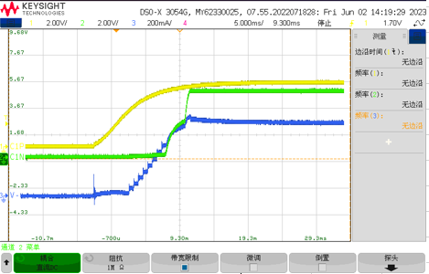 | 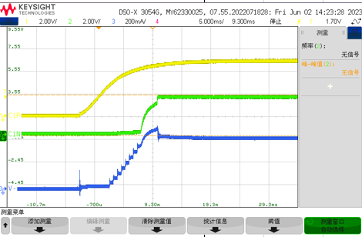
Soft-start waveform: V_{INP} =5V(yellow), V_{ISO}=5V(green), I_{ISO}=300mA(blue) | Soft-start waveform: V_{INP} =5V(yellow), V_{ISO}=3.3V(green), I_{ISO}=300mA(blue)
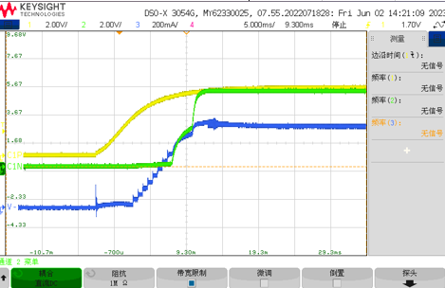 | 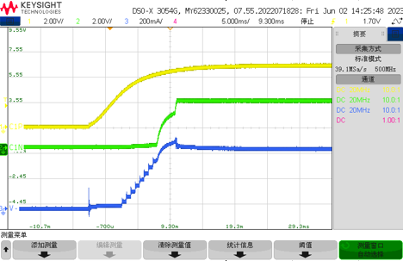
Soft-start waveform: V_{INP} =5V(yellow), V_{ISO}=5.4V(green), I_{ISO}=300mA(blue) | Soft-start waveform: V_{INP} =5V(yellow), V_{ISO}=3.7V(green), I_{ISO}=300mA(blue)
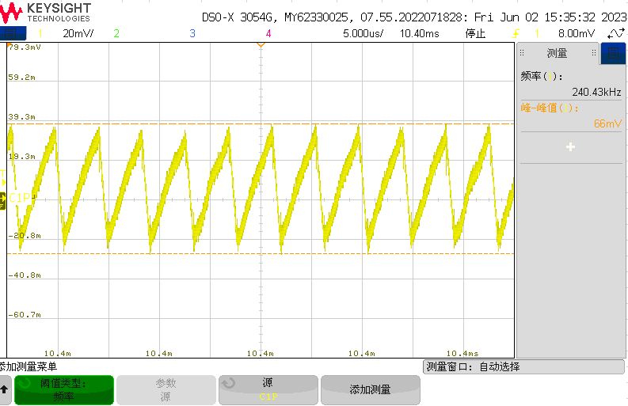 | 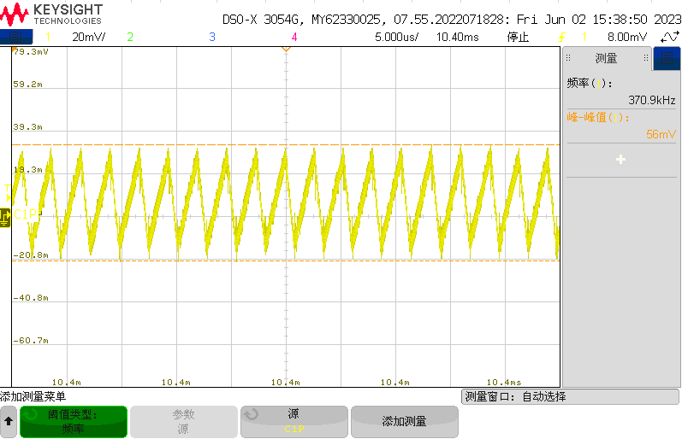
V_{ISO} ripple voltage(peak to peak): V_{INP} =5V, V_{ISO}=5V, I_{ISO}=300mA | V_{ISO} ripple voltage(peak to peak): V_{INP} =5V, V_{ISO}=3.3V, I_{ISO}=300mA
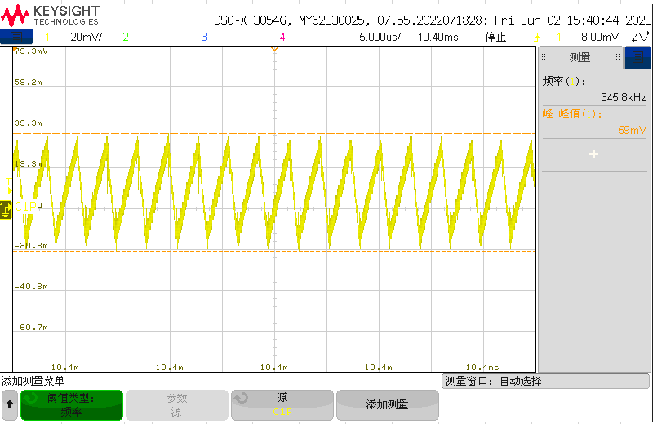 | 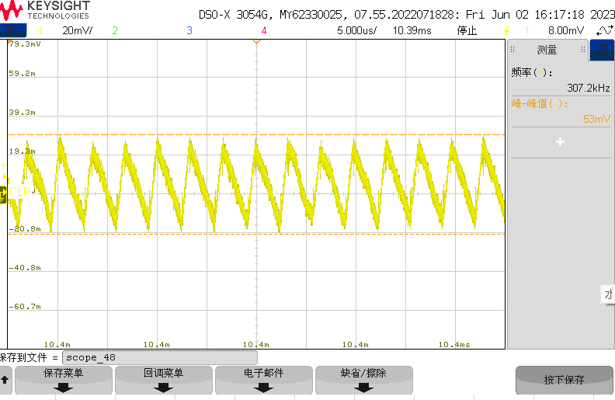
V_{ISO} ripple voltage(peak to peak): V_{INP} =5V, V_{ISO}=5.4V, I_{ISO}=300mA | V_{ISO} ripple voltage(peak to peak): V_{INP} =5V, V_{ISO}=3.7V, I_{ISO}=300mA
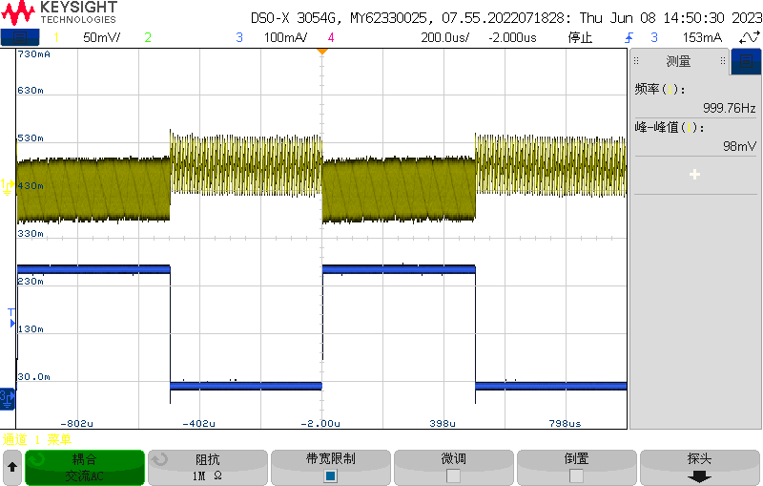 | 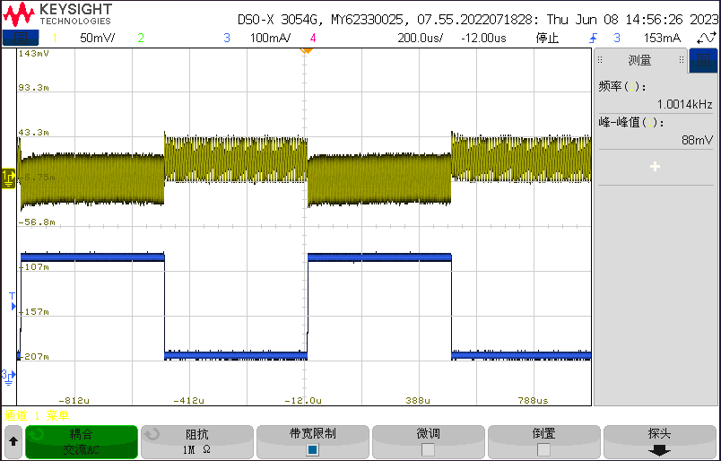
V_{ISO} Load transient response: V_{INP} =5V, V_{ISO}=5V  Load-current: 30mA/270mA | V_{ISO} Load transient response: V_{INP} =5V, V_{ISO}=3.3V  Load-current: 30mA/270mA
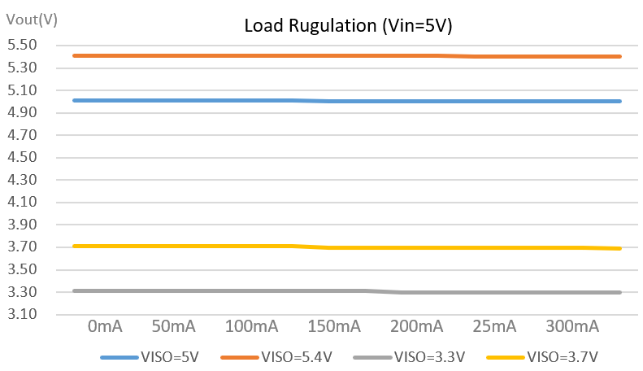 | 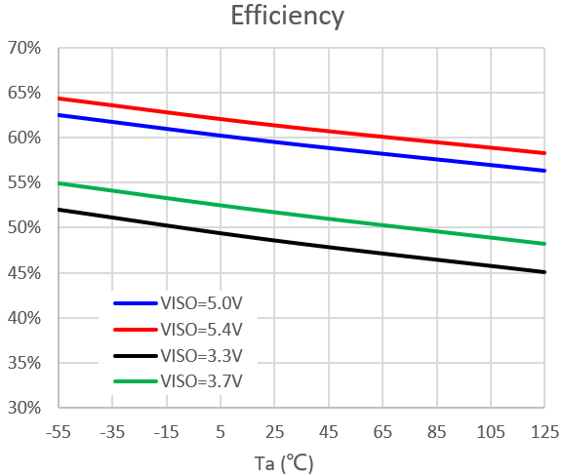
V_{ISO} load regulation: V_{INP} =5V, V_{ISO}=5V/5.4V/3.3V/3.7V  Output current: 0mA-300mA | Power supply efficiency vs. temperature  V_{INP} =5V, V_{ISO}=5V/5.4V/3.3V/3.7V, output current = 300mA
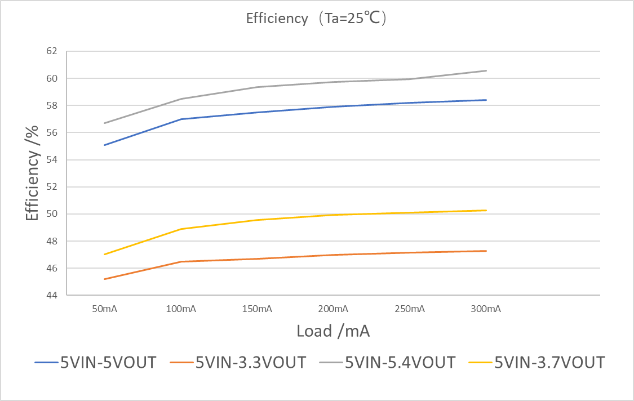 | 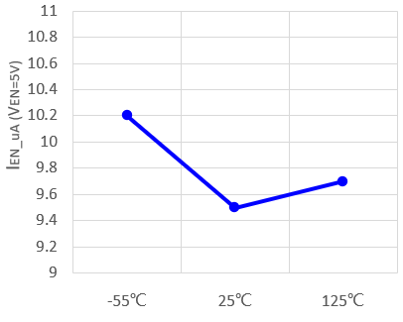
Efficiency for 5V-5V/5V-3.3V/5V-5.4V/5V-3.7V @25°C | EN Pin input current vs. temperature
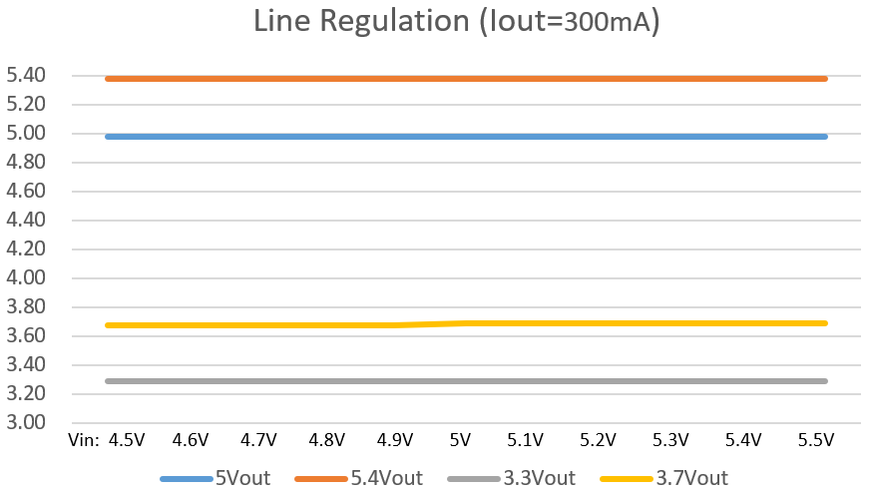 | 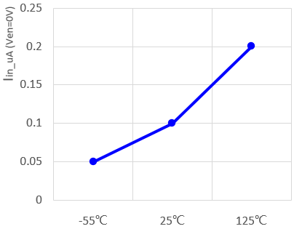
Line regulation: V_{INP} =4.5v ~ 5.5V  Output current: 300mA | VINP Pin input current vs. temperature  (EN=0V, VINP=5V)
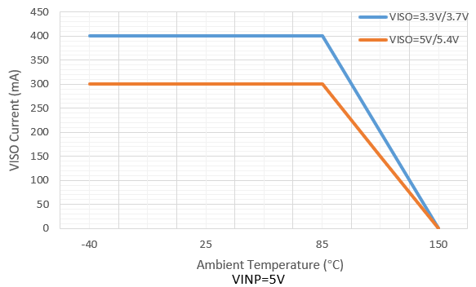 | 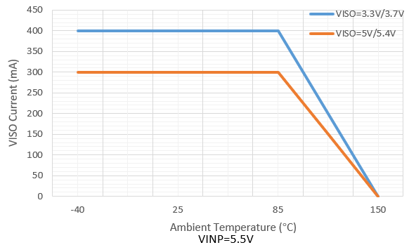
VINP=5V, output current derating vs. temperature | VINP=5.5V, output current derating vs. temperature
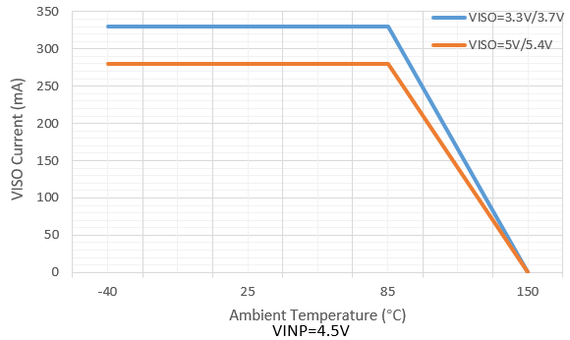
VINP=4.5V, output current derating vs. temperature

Detailed Description

Overview
The CA-IS3115AW is a family of complete isolated DC-DC converters designed to provide isolated power with up to 1.5W output power across a 5kV_{RMS} isolation barrier. The devices operate over 4.5V to 5.5V input voltage range and use a proprietary control mechanism. The input supply V_{INP} is provided to the primary power controller that switches the power stage connected to the integrated transformer. Power is transferred to the secondary side and regulated to a fixed output voltage set by the SEL pin. The soft-start feature allows to reduce input inrush current and avoid output overshoot. These devices also incorporate an output enable (EN) control and undervoltage lockout(UVLO) function that allows the user to turn on the part at the desired input-voltage level. Figure 8-1 shows the CA-IS3115AW’s functional block diagram. Connect the EN pin to VINP or force this pin high to turn on the DC-DC converter. Force this pin low to disable the device and enter low-current shutdown mode. These devices offer a ready-made, reliable, easy-to-use solution and allow users save PCB space and reduce design time for the popular 5V, 3.3V power supply systems.

These devices are provided with a robust overcurrent protection scheme that protects the devices under overload and output short-circuit conditions. A cycle-by-cycle peak current limit turns off the switching operation and triggers hiccup mode. Once the hiccup timeout period expires, soft-start is attempted again. Hiccup mode operation ensures low power dissipation under output short-circuit conditions.

Figure 8-1. Functional Block Diagrams

Output Voltage Selection
At startup, the CA-IS3115AW monitors the state of pin SEL after applying V_{INP} supply voltage above the UVLO rising threshold or enabling via the EN pin, to build the desired regulation voltage level for the V_{ISO} output. See Table 8-1 for the output voltage selection.
Table 8-1. V_{ISO} Output Voltage Selection
EN | SEL | VISO
High | Sorted to VISO | 5V
High | 100kΩ to VISO | 5.4V
High | Shorted to GNDS | 3.3V
High | 100KΩ to GNDS | 3.7V
High | OPEN | Unsupported
Low | X | 0V
Note: Don’t leave SEL pin open.

Protection Functions

UVLO and Soft-Start
The CA-IS3115AW undervoltage lockout (UVLO) on both V_{INP} power supply and V_{ISO} isolated supply. Upon power-up, the primary side transformer driver is disabled while the V_{INP} voltage is below the threshold voltage V_{UVLO+}(2.7V, typ.), and V_{ISO} output is off. The output powers up once the threshold is met. This allows the user to turn on the part at stable input-voltage level.

For many applications, it is necessary to minimize the inrush current at start-up. The CA-IS3115AW devices built-in soft-start circuit significantly reduces the start-up current spike and output voltage overshoot. Once input power supply is applied at VINP pin, the internal soft-start circuit will control the power delivered to the output gradually increase, allowing for a graceful turn-on ramp.

Current-limit Protection
The CA-IS3115AW devices are provided with an over-current protection scheme that protects the device under overload and output short-circuit conditions. A cycle-by-cycle peak current limit turns off the switching operation and triggers a hiccup mode whenever the switch current exceeds the internal current limit. Once the hiccup timeout period expires, soft-start is attempted again. The hiccup condition is cleared when the over-current is removed.

Thermal Shutdown
Thermal-shutdown protection limits total power dissipation in the device. When the junction temperature of the device exceeds 175°C(T_{SD}), an on-chip thermal sensor shuts down the device, allowing the device to cool. The thermal sensor turns the device on again after the junction temperature cools and junction temperature drops to normal operation temperature range (< 150°C ) of the device.

Applications Information

Typical Application Circuit
The CA-IS3115AW devices are high-integration isolated power supply solution. Included in the package are the switching controller, power switches, transformer, and all support components. Only output and input bypass capacitors are needed to finish the design. For the applications with LDO post regulator, it needs a single 100kΩ external resistor to set the output level to 3.7V or 5.4V, see Figure 9-1 typical application circuit.

Figure 9-1. CA-IS3115AW Typical Application Circuit

Input and Output Capacitors
The input capacitors (between VINP and GNDP) are required to reduce the peak current drawn from input power source and reduce the switching noise, increase efficiency. For the input capacitors, choose the ceramic capacitor because they have the lowest equivalent series resistance (ESR), smallest size, and lowest cost. For most applications, we recommend to use at least 0.1μF and 10μF ceramic capacitors with X5R or X7R temperature characteristic.

The output capacitors between VISO and GNDS are required as well to keep the output voltage ripple small and to ensure loop stability. These bypass capacitors must have low impedance at the switching frequency. Ceramic capacitors are recommended due to their small size and low ESR. Make sure the capacitors do not degrade their capacitance significantly over temperature and DC bias. It is recommended to have at least 10μF of effective capacitance at output.

PCB Layout Guidelines
High switching frequencies and large peak currents make PCB layout a very important part of the isolated DC-DC converter design. Good PCB design minimizes excessive electromagnetic interference (EMI) and voltage gradients in the ground plane to avoid instability and regulation errors. Even with the high level of integration, like CA-IS3115AW, users may fail to achieve specified operation with a haphazard or poor layout. So careful PCB layout is critical to achieve clean and stable operation, and ensure that the grounding and heat sinking are acceptable.

Place the input capacitors, output capacitors, and the CA-IS3115AW IC on the same PCB layer. Place decoupling capacitors as close as possible to the CA-IS3115AW device pins, see Figure 9-2 recommended components placement for the PCB layout. The paths must be wide and short to minimize inductance, also any via holes must be avoided on these paths. Connect all of the ground (GNDP, GNDS) connections to as large a plane area as possible for best heat-sinking. To ensure isolation performance between the primary side and secondary side, on the top layer and bottom layer keep the space under the CA-IS3115AW device free from traces, vias, and pads to maintain maximum creepage distance (≥ 8mm).
Figure 9-2. Recommended Bypass Capacitors Placement

Package Information
The following figure illustrates the size drawing and recommended pad size of SOIC16-WB wide-body package for the CA-IS3115AW isolated DC-DC converter. All dimensions are in millimeters.

Soldering Temperature (reflow) Profile
Figure 11-1. Soldering Temperature (reflow) Profile

Table 11-1. Soldering Temperature Parameter
Profile Feature | Pb-Free Soldering
Ramp-up rate (T_{L} = 217°C to peak T_{P}) | 3°C/s max
Time t_{s} of preheat temp (T_{smin} = 150°C to T_{smax} = 200°C) | 60~120 seconds
Time t_{L} to be maintained above 217°C | 60~150 seconds
Peak temperature T_{P} | 260°C
Time t_{P} within 5°C of actual peak temp | 30 seconds max
Ramp-down rate (peak T_{P} to T_{L} = 217°C) | 6°C/s max
Time from 25°C to peak temperature T_{P} | 8 minutes max

Tape and Reel Information

REEL DIMENSIONS
TAPE DIMENSIONS

A0 | Dimension designed to accommodate the component width
B0 | Dimension designed to accommodate the component length
K0 | Dimension designed to accommodate the component thickness
W | Overall width of the carrier tape
P1 | Pitch between successive cavity centers

QUADRANT ASSIGNMENTS FOR PIN 1 ORIENTATION IN TAPE

*All dimensions are nominal
Device | Package Type | Package Drawing | Pins | SPQ | Reel Diameter (mm) | Reel Width W1 (mm) | A0  (mm) | B0  (mm) | K0  (mm) | P1  (mm) | W  (mm) | Pin1 Quadrant
CA-IS3115AW | SOIC | W | 16 | 1000 | 330 | 16.4 | 10.9 | 10.7 | 3.2 | 12.0 | 16.0 | Q1

Important statement
The above information is for reference only and used for helping Chipanalog customers with design, research and development. Chipanalog reserves the rights to change the above information due to technological innovation without advance notice.
All Chipanalog products pass ex-factory test. As for specific practical applications, customers need to be responsible for evaluating and determining whether the products are applicable or not by themselves. Chipanalog's authorization for customers to use the resources are only limited to development of the related applications of the Chipanalog products. In addition to this, the resources cannot be copied or shown, and Chipanalog is not responsible for any claims, compensations, costs, losses, liabilities and the like arising from the use of the resources.

Trademark information
Chipanalog Inc.® and Chipanalog® are registered trademarks of Chipanalog.


http://www.chipanalog.com

